**"From Toxicity to Therapeutics: Discovering the Soil Antibacterial Potential of Selected Ornamental Flora"**

**Ornamental Horticultural Crops of India:** Diversity, toxicity, and chemical composition

Decorative plants are cultivated for their beauty in gardens and landscape gardening, as indoor plants, cut flowers, and specimens, and are a part of mankind since time immemorial. About 406,700 plant species are found on our planet, and of the plants, 85,000–99,000 plant species possess ornamental worth like trees, shrubs, climbers and creepers, palms, ferns, orchids, grasses, bamboos and reeds, cacti and succulents, annuals, bulbs, and other flowering crops, covering the tropical, subtropical, and temperate regions of the globe. The ornamental plant market keeps on growing day by day but simultaneously goes through periodic trend-oriented fluctuations.

In fact, annually, hundreds of new cultivars, which substitute the existing range, are developed. Thus, this diversity among ornamentals is a major breeding material supply for the creation of new varieties. This is why protection and storage of these precious genetic resources are so important to always be able to satisfy the needs of the market. Conservation of the Earth's ornamental crops' biodiversity is an ongoing process of evolution for human use due to changes in garden design as well as for commercial exploration of various flowering crops.

Here, a varied range of ornamental species along with their conservation methods through different approaches are narrated. Currently, ornamental germplasm are conserved in situ and ex situ in the forest, national parks, botanical gardens, and arboreta. Moreover, the application of recent biotechnological techniques, from seed drying to the cryopreservation of embryos, pollens, etc., has acted as a boon towards the conservation of the diversification of the ornamentals as well as to produce good-quality planting materials that are accessible to the real market of ornamental plants.

Ornamental flowers widely grown in India have a vast array of bioactive molecules—such as flavonoids, polyphenols, alkaloids, terpenoids, tannins, saponins, and essential oils—which confer both therapeutic and toxicological attributes.

Accordingly, ornamental plants represent promising leads for new medicines; their dual potential as medicines and poisons emphasizes the need for careful pharmacological and toxicological evaluation before they are used in primary healthcare or phytopharmaceutical products

|  |  |  |
| --- | --- | --- |
| **Plants** | **Chemical composition** | **Toxicity** |
| Philodendron x 'Xanadu' | Calcium oxalate crystals (raphides); alkenyl resorcinols | Mucosal irritation of the oral cavity, burning, swelling, oral edema; occasional systemic toxicity |
| Peace Lily (Spathiphyllum spp.) | Calcium oxalate crystals, steroidal glycoalkaloids, saponins | Lip/mouth swelling, vomiting, dysphagia; in rare extreme cases can impact the airways |
| Golden Dewdrop (Duranta erecta) | Iridoid glycosides (acteoside, repenins, etc.), phenylethanoid glycosides, flavonoids, steroids, terpenoids, saponins, tannins | Gastrointestinal and neurotoxic symptoms harm the liver |

**Abstract**

Antibiotic resistance is a growing global problem that affects not only people, but also animals, the environment, and the economy. Many clinically relevant bacteria have become resistant to antibiotics, which is emerging as one of the major threats to public health. The lack of new antibiotics, delays in clinical trials, and time-consuming and costly development all contribute to health problems. Therefore, it is necessary to identify new antimicrobial agents to treat bacterial and fungal infections. Plant extracts, which are valuable sources of bioactive compounds, mainly polyphenols, play an important role as a new strategy to combat pathogenic microorganisms. Some common ornamental plants such as Philodendron xanadu, Golden Dewdrop (Duranta erecta), and Peace Lily (Spathiphyllum spp.), are commonly known to be toxic because of their possible detrimental impact on humans and animals. Even though they are toxic, there is growing evidence that suggests these have great antimicrobial activity, especially against soil bacteria. For antimicrobial potential of the *Philodendron* genus, see also references (González Montiel, L., Güemes Vera, N., Soto Simental, S., & Campos Pastelin, J. M. (2019)), Golden Dewdrop (Duranta erecta)Exhibits inhibitory effects against multiple bacterial and fungal strains ([ScienceDirect Review](https://www.sciencedirect.com/science/article/abs/pii/S0378874122003130)). Nonetheless, the range and modalities of their antimicrobial action are insufficiently investigated. The current study seeks to critically examine the antimicrobial activity of extracts from these toxic plants against soil bacterial isolates. Through this study, we seek to bridge the gap between the known toxicity of these species and their possible use as safe and effective antimicrobial resources. In addition, the antimicrobial activity of Philodendron xanadu extract was greater than that of the Azadirachta indica (neem) leaf extract, which is evidenced by the significantly higher CFU decrease of soil bacterial isolates. This observation indicates that in contrast to the widely reported broad-spectrum antibacterial activity of neem, Philodendron xanadu demonstrates superior bactericidal activity under the experimental conditions. Furthermore, some polyphenols show a synergistic effect when combined with antibiotics and antifungals, suggesting a promising alternative for therapeutic strategies against antibiotic resistance. Hence, this review focuses on the antimicrobial activity of polyphenols and extracts rich in polyphenols on clinical isolates, against soil microbes. In conclusion the increased antimicrobial efficacy of Philodendron xanadu highlights its potential as a highly effective natural antimicrobial compound and justifies its potential use in biopesticidal products or drug development, especially for soil-borne bacterial diseases.

**INTRODUCTION**

India is placed among the top 12 mega-diverse nations globally and has around 7-8% of all plant, animal, fungi, and microorganism species. India's floristic spectrum consists of around 45,500 species, and more than 5285 species are found to be endemic (NBA 2012, 2018). Medicinal plants have been a source of healing in local communities across the globe for centuries. Even so, it continues to be of modern relevance as a first mode of healthcare for about 85% of the global population (Pešić, 2015) Growing fascination with research and analysis of medicinal plants is evident in recent publications, with over three times more than 4,686 reported within the year 2008 to 14,884 in 2018 It is noteworthy that Indian Systems of Medicine (Ayurveda, Siddha, Unani, Amchi), and so on utilizes only 2500 plants, whereas there are collection of 10,000 plants which must be scientifically proven. *Indian Systems of Medicine: A Brief Profile* (PMC, 2007), Harwansh, R. K., Banerjee, S., & Kar, A. (2024). Among these, 8000 wild plant species used by tribals for medicinal purposes, roughly 950 are found to be new claims and deserving of scientific examination. Around 3900 or more wild plant species are utilized as subsidiary food/vegetables by the tribals. Among the 400 plant species utilized as fodder, 100 are worth recommending for extensive utilization. Approximately 300 wild species are utilized by tribals as pesticides. At least 175 of them are highly promising to be formulated as safe pesticides. They are also a source of a variety of natural products with diverse therapeutic properties and are being studied every day to create new drugs. India boasts a strong history of herbal medicine and has excellent contributions in terms of Ayurveda & Siddha but also in the establishment of new modern drugs and pharmacological studies. Singh, S., & Boaz, R. J. (2015). Antimicrobial drugs are the major contenders which contribute to modern medicine. (Morandi, Minniti, & Nambi, 2025) So far, many secondary metabolites with varied structures and pharmacological activities have been isolated from plants [31, 78]. Over 85–90% of the global population relies on the traditional drug system for the treatment of various diseases. Overview of traditional medicine’s global role and ongoing strategies for safe use of plant-based medicines (Journal of Neonatal Surgery, 2025). Infectious diseases continue to be among the major causes of death globally, especially in middle- and low-income countries. Notwithstanding the progress of modern medicine, the growing drug resistance among pathogens and misuse of man-made antibiotics have escalated the global health crisis. Based on the Global Burden of Disease Study 2024 and WHO's World Health Statistics 2024:

Bacterial infections continued to be the second-leading cause of mortality in the world, following ischemic heart disease. The major infection types are lower respiratory infections (such as pneumonia). These conditions put spotlight to the necessity of alternative and efficacious therapeutic concepts which are effective and sustainable. In this category, natural plant-based therapies have drawn global attention based on their broad-spectrum antimicrobial activities, low reactivity, and their past applications in traditional medicine. Plants synthesize secondary metabolites, including terpenes, phenolics, alkaloids, and nitrogenous compounds, that are antimicrobial in nature and enable them to combat pathogens, pests, and environmental stress. Possess diverse pharmacological activities and have essential biological functions. They are both a defense mechanism against pathogen infection and an excellent source of drugs. The involvement of microorganisms in regulating plant secondary metabolites is well established. And these metabolites have the ability to promote or inhibit the microbiome since they affect the biosynthetic pathways, such as the phenylalanine pathway. Since reports about rising drug resistance in human pathogens, as well as unwanted side effects of some antimicrobial agents, necessitate the search for new agents that are more potent, less costly, and side-effect-free to treat infectious diseases, numerous diverse plant/natural products are employed for the treatment of infections. There have been several reports on the pharmacological effects and suitability of medicinal plants as phytotherapies for diseases. Fruit and leaf extracts have been reported to possess anti-inflammatory, analgesic, and immunoprotective effects. For this research, the in vitro antimicrobial activity of ornamental plants tagged as toxic Philodendron xanadu, Peace Lily, Golden Dewdrop, compared it with neem antimicrobial applications against soil is of prime interest. As there are no established direct antimicrobial or medicinal effects for Philodendron Xanadu in relation to bacterial inhibition reported in scientific literature.

**Botanical Samples and Collection**

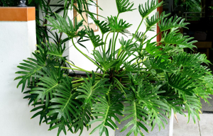

FIG : ( *Philodendron Xanadu)*

Here are the properties of each plant used in the experiment, focusing on their scientific and bioactive significance:

1. **Scientific name: *Philodendron x*'Xanadu'**

**( *Philodendron xanadu*Croat, Mayo & Boos 2002)**

**Common name(s):**'Xanadu' philodendron

**Family:***Araceae*

**Plant type:**perennial; shrub

Philodendron xanadu is a subshrub or herbaceous plant, belonging to the philodendron genus Xanadu does well in the shade of large trees. It requires quite rich, water-retentive soil in order to appear at its best. The majority of philodendrons transition to alkaline soil quite nicely and also tolerate drought. It is best to plant it in semi-shade or filtered light, in fertile, humus-enriched, and regularly irrigated soil. Prefers tropical heat and humidity, but can stand the subtropical or southern temperate cold. Philodendron xanadu, which belongs to the family Araceae and Philodendron section Meconostigma, is thought to have originated in southeastern Brazil (Boos, 2008). Xanadu philodendron can be susceptible to aphids, mealy bugs, scale, thrips, and spider mites. This species is susceptible to fungal leaf spots, and one must avoid overwatering. poisonous to vertebrates but differing in their toxicity. They have raphide bundles of calcium oxalate crystals, which are toxic and irritating. The sap is irritating to the skin. Chewing and/or ingestion of plant parts can cause extreme swelling and impaired respiratory functions. **Air Purification:** Acts as an efficient air purifier by removing toxins such as formaldehyde, benzene, and trichloroethylene, thereby improving indoor air quality[1](https://cafeplanta.com/blogs/resources/philodendron-xanadu-benefits)[2](https://www.gardenia.net/plant/philodendron-xanadu-thaumatophyllum-xanadu)[4](https://krishnanursery.in/Indoor-Plants/79-golden-xanadu-plant.html)[7](https://www.ugaoo.com/products/philodendron-xanadu-plant-green)[9](https://krishnanursery.in/Indoor-Plants/64-green-xanadu-air-purifier-cleaner-plant.html)[10](https://nurserylive.com/products/philodendron-xanadu-golden-small-plant).**Stress and Mood:** The presence of this plant is associated with reduced stress and enhanced mood, likely via its contribution to a calming environment[1](https://cafeplanta.com/blogs/resources/philodendron-xanadu-benefits)[5](https://planaplant.com/products/philodendron-xanadu-plant-green)[10](https://nurserylive.com/products/philodendron-xanadu-golden-small-plant).**Humidity Regulation:** Releases moisture through transpiration, helping balance indoor humidity levels[1](https://cafeplanta.com/blogs/resources/philodendron-xanadu-benefits).**Allergen Relief:** By improving air quality and humidity, it can decrease the prevalence of airborne allergens[1](https://cafeplanta.com/blogs/resources/philodendron-xanadu-benefits).**Growth Habit and Toxicity:** Although valued as an ornamental, Philodendron xanadu is toxic if ingested due to calcium oxalate crystals, which can cause oral and gastrointestinal irritation in humans and animals[2](https://www.gardenia.net/plant/philodendron-xanadu-thaumatophyllum-xanadu)[3](https://housing.com/news/philodendron-xanadu-winterbourn/). There are no proven direct antimicrobial or medicinal effects relevant to bacterial inhibition documented in scientific literature[8](https://greencoverinitiative.com/leafy-plants/thaumatophyllum-xanadu/).

**2. Peace Lily (Spathiphyllum spp.)**

**Common Name(s**): Peace Lily, Spathe, Spathiphyllum

**Family**: Araceae

**Plant Type**: Evergreen herbaceous perennial plant

Peace lilies are well-liked indoor houseplants that are valued for their exquisite white or greenish-white spathe flowers and glossy, dark green leaves. They are herbaceous perennials that grow evergreen and usually reach a height of 1 to 6 feet. Spider mites, mealy bugs, and aphids are the three insects that prey on peace lilies. Aphids: Look for aphids if sticky slime starts to cover your plant. Mealy bugs: Check for mealy bugs and a cottony mass between the plant's stems and leaves if your foliage starts to turn yellow and dry. Spider Mites: You may have a spider mite infection if you notice brown patches on your leaves and "webbing" between them. Wikipedia contributors. (2005, April 17), North Carolina State University. (2025, May 21).**Air Purification:** Effective at removing indoor air pollutants such as benzene, formaldehyde, and trichloroethylene, as confirmed by several NASA Clean Air Studies.**Antimicrobial Activity:** Aqueous and methanolic extracts have shown moderate antibacterial activity against various pathogens in some studies, attributed to phytochemicals like alkaloids and phenolics.**Humidity Regulation:** Enhances humidity via transpiration, which can reduce dry air symptoms and respiratory irritants.**Toxicity:** Contains calcium oxalate, making it toxic to humans and pets if consumed, causing irritation and potentially more serious symptoms.

**3. Neem (Azadirachta indica)**

**Common Names:**Neem, Indian lilac, Margosa

**Family:**Meliaceae

**Plant Type:**Evergreen tree, medicinal and pesticidal plant

Native to the Indian subcontinent, neem is an evergreen tree that is well-known for its numerous applications in pest management, agriculture, and traditional medicine. It produces seeds that yield neem oil, which has antimicrobial, antifungal, and insecticidal qualities due to the presence of bioactive compounds like salannin, nimbin, and azadirachtin. The pharmacological potential of neem includes immunomodulatory, anti-inflammatory, and anti-cancer properties. Due to its diverse mode of action on insects, which includes growth-regulating, oviposition-inhibiting, repellent, and antifeedant properties, neem demonstrates strong pest resistance. It is an environmentally friendly substitute for synthetic pesticides because it interferes with insect development, molting, and reproduction. The bioactive substances in neem have little toxicity to beneficial organisms that are not the intended target and lessen the possibility of pest resistance. Sharma, R. C., Lavanya, V., Kumar, A., Prasanna, K. L., & Kumar, M. (2023), Campos, E. V. R., de Oliveira, J. L., Fraceto, L. F., & Singh, B. (2016)**Strong Antimicrobial Properties:** Demonstrated broad-spectrum antibactericidal and fungicidal properties, effective against both gram-positive and gram-negative bacteria. Active constituents include azadirachtin, nimbin, and gedunin.**Antioxidant and Anti-inflammatory:** Contains polyphenols, flavonoids, and other compounds shown to reduce oxidative stress and inflammation.**Traditional Medicinal Uses:** Extensively used in traditional medicine for its antibacterial, antiviral, and wound-healing properties. **Non-Toxic for External Use:** Generally safe in topical applications, though ingestion in large amounts can be toxic.

**4. Golden Dewdrop (Duranta erecta)**

**Common Names**: Golden Dewdrop, Pigeon Berry, Skyflower

**Family**: Verbenaceae

**Plant Type:** Evergreen shrub or small tree

Native to tropical Americas, such as southern Florida, Mexico, and the Caribbean, Duranta erecta is a prickly evergreen shrub or small tree that grows quickly. It yields loose clusters of violet-blue to lavender flowers that bloom from summer through fall, along with glossy, rich green ovate leaves. The plant produces eye-catching berries that range in color from golden yellow to orange. These berries are poisonous to humans and most animals because they contain hydrocyanic acid, saponin glycosides, and isoquinoline alkaloids. The plant grows 2 to 6 meters tall, prefers well-drained soil, and does best in full sun. Phytochemical and Biological Properties: The plant and its extracts are of interest for both traditional and possible medical applications because they contain compounds that have been shown to have antioxidant, antimicrobial, and insecticidal effects. Gardenia.net. (2023, April 10), University of Florida IFAS Extension. (2024, June 12), Subsongsang, R., et al. (2016) **Antibacterial Properties:** Leaf extracts have demonstrated inhibitory effects on both gram-positive and gram-negative bacteria in vitro, attributed to flavonoids, saponins, and tannins. **Antioxidant Activity:** Contains diverse secondary metabolites with free-radical scavenging capacity. **Ornamental and Caution:** Widely grown as an ornamental; however, its berries are toxic to humans and many animals if ingested.

**Methodology**

Plate counting, a traditional quantitative method in microbiology, was used to isolate and determine the antimicrobial activity of plant extracts against soil bacteria by counting colony-forming units (CFUs) after incubation on solid agar medium. Originally formalized in the early 20th century, the plate count approach offers a direct estimation of viable bacterial populations and remains a gold standard for microbial enumeration due to its relative simplicity, sensitivity, and ability to yield discrete colonies for subsequent analysis (Bankier et al., 2018; Breed & Dotterrer, 1916). This approach captures decreases in CFUs with exposure to antimicrobial phytochemicals as a direct measure of inhibitory activity over defects of optical density-based or colorimetric assays in heterogeneous soil communities. The spread plate method enables recovery and isolation of single colonies of bacteria, enabling not just reliable quantitation but also morphological inspection and possible sub-culturing of resistant or sensitive strains. Its use in this research gives semi-quantitative confirmation of antimicrobial activity by contrasting the differential colony numbers in treated and control groups, a strong, repeatable measure extensively proved in microbiological studies and industrial settings (Bankier et al., 2018; ScienceDirect Topics, n.d.). While newer high-throughput techniques like flow cytometry or qPCR provide further layers of quantification, plate count is still extremely useful in mixed, complex microbial environments like soil, where the culturability and viability of target organisms need to be consistently separated and correlated with bioactive treatments.

The viable number of living aerobic bacteria is ascertained with a plate count agar which is a bacterial growth substrate. The medium has casein which offers nitrogen, carbon, amino acids, vitamins and minerals to promote the growth of the organism. Yeast extract is a source for vitamins, especially of B-group. Glucose is a fermentable carbohydrate and agar is the gelling agent. This is a non-selective medium and the bacteria is quantitated as colony forming units per gram (CFU/g) in solid samples and (CFU/ml) in liquid samples.

**Pour plate technique**

The pour plate technique is the most common method of preparing plate count agars. In this method, the inoculum is placed into the molten agar prior to pouring the plate. The molten agar is cooled to around 45 degrees Celsius and is aseptically poured into a petri dish with a predetermined diluted sample. The plates are then shaken to distribute the samples evenly into the agar. Incubation of the plates follows and is done for approximately 3 days at 20 to 30 degrees Celsius.

One of the most basic microbiological methods is plate counting which is applied to ascertain the number of viable (i.e. living) cells within a sample. There are various steps to the procedure and all should be performed with care in order to gain reliable results. Aseptic technique should be employed throughout. Aseptic technique is the name used for a series of procedures that are meant to prevent the sample from being contaminated. This includes holding the tubes at an angle, flaming bottle lids, the use of sterile pipettes etc.

**Plate counting method**

**Step One: Diluting the sample**

Depending on where the sample came from there could be thousands, millions or even billions of microorganisms per millilitre of sample. There are too many for us to count so we dilute the sample.1ml of sample and 9ml of an appropriate diluent (e.g. sterile buffer) are mixed together .The sample and diluent are shaken until mixed .This fresh sample (Dilution One) is 1/10th as concentrated (number of microorganisms per ml) as the original sample.1ml of Dilution One is mixed with another 9ml of diluent to create Dilution Two .Dilution Two is 1/10th as concentrated as Dilution One and 1/100th as concentrated as the original sample.This continues until we have a range of dilutions

**Step Two: Plating the sample**

To determine how many living cells are in each of our dilutions we must place some of the sample on an agar plate. An agar plate is made by adding growth medium and agar together and autoclaving to sterilize. After the agar cools down to ~50oC about 15ml is added to a sterile Petri dish and allowed to solidify.0.1ml of sample is pipetted onto the surface of the agar and spread around with a sterile glass rod. We normally place 0.1ml of one of our dilutions of the sample on to a plate – if we place more than this on it can make the plates extremely wet and if we place less than this on, it's hard to spread evenly. This is done again so that we have 2 or 3 replicate plates for our initial sample and for each of our dilutions. All this is a lot of plates and would potentially become very expensive and time consuming.

**Preparation of Nutrient Media for Antimicrobial Assays**

The nutrient medium used in this research was Nutrient Agar (NA), chosen because of its wide-range applicability to promote heterotrophic bacterial growth in soil. The medium was prepared by suspending specific amounts of peptone (as a universal source of nitrogen and carbon), beef extract (source of necessary vitamins and factors for growth), and agar (gelling agent) in distilled water. The pH was adjusted carefully to 7.2 ± 0.2 using sterile 1N NaOH or HCl to enhance bacterial growth. The combination was sterilized by autoclaving at 121°C under the pressure of 15 psi for 15 minutes to attain asepsis and inactivate any adventitious microbial contaminants. After autoclaving, the agar cooled to around 45–50°C before being aseptically dispensed into sterile Petri dishes to prevent condensation and allow uniform solidification. Plates were set under biosafety laminar flow to solidify. For antimicrobial susceptibility testing, soil bacterial isolates were uniformly inoculated on the surface of the agar using the standard spread plate method, providing confluent bacterial lawns*.* After solidification, 1 mL of the corresponding plant extract was aseptically pipetted and evenly spread over the agar surface using a sterile glass spreader to ensure uniform distribution. Plates were allowed to air dry under aseptic conditions in a laminar flow hood. Plates were incubated at 37°C for 24–48 hours to allow bacterial growth and diffusion of the extracts. Plates are incubated at 37°C for 18–24 hours, and zones of inhibition are taken to measure antimicrobial activity (Daoud et al., 2018)The use of Nutrient Agar gives a chemically defined, nutritionally enriched environment that is conducive to consistent bacterial growth, essential to allow reproducible and comparative antimicrobial efficacy measurements.Such standardized protocol allows comparative assessment of antimicrobial efficacy in a variety of botanical extracts against microbial isolates from soil, in line with protocols established in previous studies (Daoud et al., 2018; Das et al., 2009

**Aseptic Soil Sampling and Serial Dilution for Quantification of Soil Bacterial Loads**

Soil samples were obtained aseptically from the rhizosphere, the biologically active zone surrounding plant roots, acknowledged as the most significant microenvironment for microbial interactions. Sampling employed sterilized metal spatulas to prevent contamination, and samples were transferred at once to sterile, labeled containers. For the purpose of achieving representativeness and minimizing heterogeneity-induced bias, composite soil samples were drawn by combining several subsamples drawn randomly from the root environment at a uniform depth (15–25 cm), by employing standard soil microbiology procedures (Habtewold et al., 2018; PGRO, 2021).Samples were homogenized aseptically on receipt in the laboratory. To quantify microbial load, a serial dilution series was made from 1 g of bulk soil in 9 mL of sterile isotonic saline (0.85% NaCl), which resulted in a primary (10⁻¹) dilution. Serial decimal dilutions (to 10⁻⁶ or as needed) were performed by pipetting 1 mL aliquots of the preceding dilution into 9 mL of clean sterile saline with vigorous vortexing to ensure even distribution of soil microorganisms, maximizing homogeneity and accuracy of dilution (Habtewold et al., 2018; EPA, 2015).Aliquots of appropriate dilution levels were plated on nutrient agar for the colony-forming unit (CFU) counting. Dilution plating makes it possible to quantify viable microbial populations, thus allowing subsequent assays for antimicrobial activity determination of plant extracts. Such serial dilution procedures are in harmony with standardized microbiological procedures for isolation and counting of soil-borne bacteria (Habtewold et al., 2018; EPA, 2015).

**Optical Density (OD) Measurement:**  
Microbial density measurements have general application in microbiology research and associated bio‐industry. Optical density (OD) is frequently employed to describe the turbidity of microbial cultures, a measure of cell density. Typical OD measurements are taken by spectrophotometers as a determination of a light source approximately 600 nm wavelength (OD600) after passage through 10 mm of suspension 1, 2. The law behind this approach is the Beer–Lambert law that stipulates the relationship between absorbance of light and the molar concentration of the solute in the solutions uniformly distributed as A = ϵcl, where c is molar concentration, ϵ is the molar extinction coefficient, and A is the absorbance 3. The optical density term is applied instead of absorbance when referring to microbial densities as homogenously distributed cell particles in suspensions scatter as well as absorb light. Spectrophotometers are the best for quantifying microbial concentrations since they yield easy, effective, and economical OD readings .At each dilution, 5 mL of the soil suspension in nutrient broth were transferred into sterile test tubes. These tubes were incubated with shaking at 37°C. Bacterial growth was monitored by measuring optical density (OD) at 600 nm using a UV-Visible spectrophotometer at one-hour intervals for up to 8 hours. Blank corrections were made using uninoculated nutrient broth.

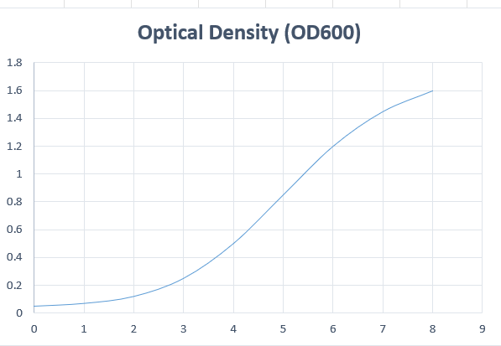

FIG 5: **Microbial Growth Curve: Optical Density /Incubation Time**

The graph depicts the traditional stages of bacterial population growth:

Lag Phase (0–1 hr): Stage of cellular adjustment and metabolic conditioning.

Exponential (Log) Phase (1–6 hr): Rapid binary division and maximum rate of growth, expressed as a sharp increase in OD.

Stationary Phase (6–7 hr): Depletion of nutrients and build-up of waste products; rate of growth equals rate of death.

Decline (Death) Phase (7–8 hr): Net loss of living cells; drop or leveling off in OD.

***Preparation of Plant Extracts:***Natural compounds, like plants extract, in the form of pure compounds or as standardized extracts, offer limitless prospect for novel drug discovery due to the unparalleled diversity of chemicals available (Cos et al., 2006). The World Health Organization (WHO) states that over 80% of the total global population depends on traditional medicine for their core health care requirements. The utilization of herbal drugs in Asia is a historical trend of human experiences with the environment. Medicinal plants possess a variety of compounds that can be applied to manage chronic and infectious conditions (Duraipandiyan et al., 2006). Extraction is the initial major step in medicinal plant analysis, since one must extract the chemical compounds of interest from the plant materials for subsequent separation and identification. The fundamental operation entailed procedures, like preliminary washing, drying of plant material or freeze drying, milling to get a homogeneous sample and usually enhancing the kinetics of analytic extraction and also enhancing the exposure of sample surface with the solvent system. Correct measures need to be undertaken to ensure that possible active constituents are not lost, deformed or destroyed in the process of preparation of the extract from plant material. If the plant was chosen based on traditional usage (Fabricant and Farnsworth, 2001), then it is required to produce the extract as presented by the traditional healer in order to replicate as closely as possible the traditional 'herbal' medicine. Solvent system selection is largely determined by the general nature of the targeted bioactive compound. Various solvent systems are used to extract the bioactive compound from natural products. such as methanol,90%acetone, Moreover, plant extracts also get prepared by maceration or percolation of freshly harvested green plants or dried powdered plant material in water and/or organic solvent systems. The other contemporary extraction methods are solid-phase micro-extraction, supercritical-fluid extraction, pressurized-liquid extraction, microwave-assisted extraction, solid-phase extraction, and surfactant-mediated methods, which have some advantages. The ease of automation for these techniques also favors their usage for the extraction of plant materials (Huie, 2002)

**Preparation of Culture Plates:**  
Sterile Petri plates were prepared by pouring approximately 20 mL of molten nutrient agar (maintained at 45–50°C) into each plate. After solidification, 1 mL of the corresponding plant extract was aseptically pipetted and evenly spread over the agar surface using a sterile glass spreader to ensure uniform distribution. Plates were allowed to air dry under aseptic conditions in a laminar flow hood.

**Inoculation of Plates:**  
From each serial dilution, 100 µL of the soil solution was aseptically pipetted and spread onto the surface of the agar plates already supplemented with the respective plant extracts. Control plates containing nutrient agar without plant extracts but inoculated with diluted soil samples were also prepared.

**Incubation and Colony Enumeration:**  
The inoculated plates were incubated in an inverted position at 37°C for 24 hours. After incubation, the plates were examined for the presence of bacterial colonies. Colony-forming units (CFU) were counted, and results were expressed as CFU/mL of original soil suspension. Antibacterial activity was inferred by comparing CFU counts between extract-treated and control plates.

**Data Analysis:**  
All experiments were performed in triplicate for statistical rigor. Results were recorded as mean ± standard deviation. Data were subjected to statistical analysis, such as ANOVA, to determine the significance of differences between treatments.

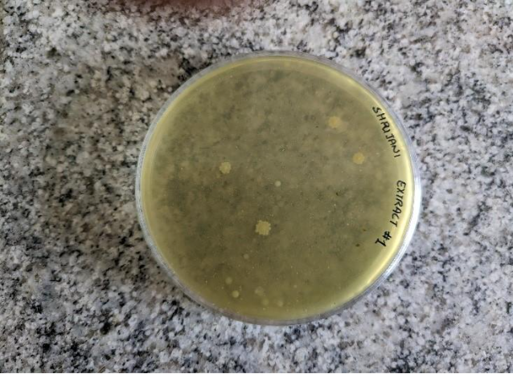

**Plate 1: Philodendron (Thaumatophyllum xanadu) Extract**

* Exhibited the **lowest level of bacterial colony formation**, indicating pronounced antibacterial activity. Quantitative colony-forming unit counts reflect significant inhibition relative to other tested extracts.
* Microscopic examination revealed predominance of rod-shaped bacteria.
* Gram staining resulted in pink coloration, confirming that the residual bacteria were predominantly Gram-negative.
* These findings suggest that compounds present in Philodendron extracts exert a broad-spectrum bactericidal or bacteriostatic effect, with greater activity against Gram-positive bacteria, resulting in selection for Gram-negative isolates. This high efficacy aligns with literature demonstrating the potential of plant-derived compounds as natural antimicrobials, which can disrupt cell wall synthesis and membrane integrity in sensitive microbial taxa.

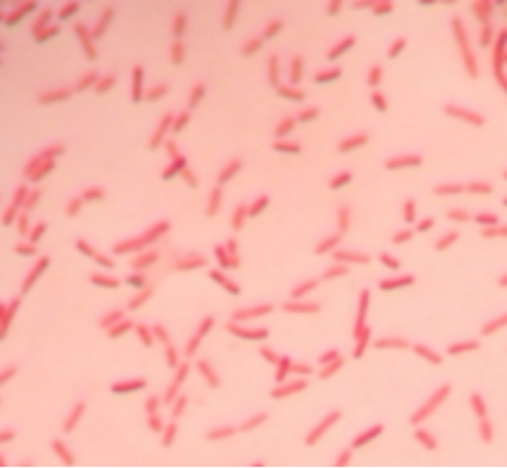

Gram Staining –Gram negative

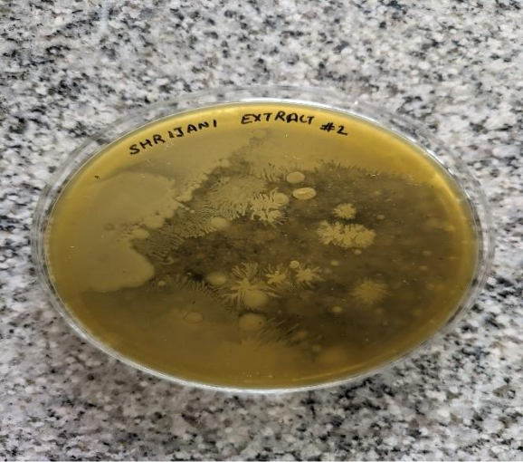

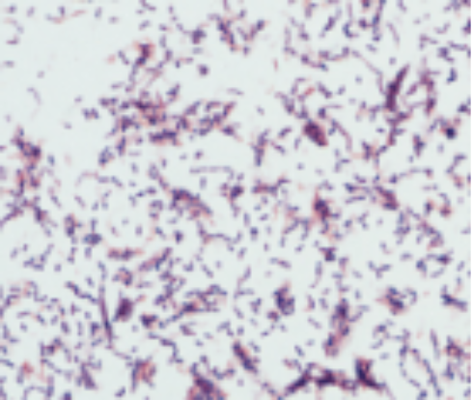

Gram Staining –Gram positive

**Plate 2: Peace Lily (Spathiphyllum wallisii) Extract**

* Showed **extensive bacterial growth** and high levels of contamination. Morphologically, both rod- and cocci-shaped cells were observed.
* Gram-positive characteristics dominated the population, as evidenced by purple retention in Gram staining.
* The limited antibacterial effect observed here may be attributed to the lower concentrations or intrinsic activity of bioactive phytochemicals within Peace Lily, which is consistent with previous reports that not all plant extracts yield significant antimicrobial effects

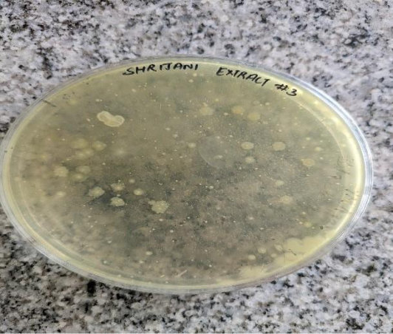

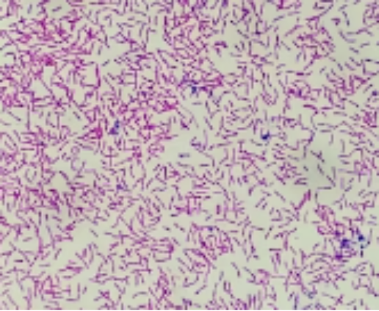

Gram staining – gram positive

**Plate 3: Neem (Azadirachta indica) Extract**

* Demonstrated **marked antibacterial activity**, as indicated by reduced colony numbers, though not to the same extent as Philodendron. Rod-shaped bacteria were predominantly identified.
* Gram staining identified the prevailing bacteria as Gram-positive.
* Neem extracts are widely documented for their broad-spectrum antibacterial properties, primarily mediated by constituents such as azadirachtin and nimbin, which disrupt bacterial cell membrane integrity and metabolic pathways. The observed reduction in Gram-positive microbial load substantiates Neem’s recognized pharmacological utility.

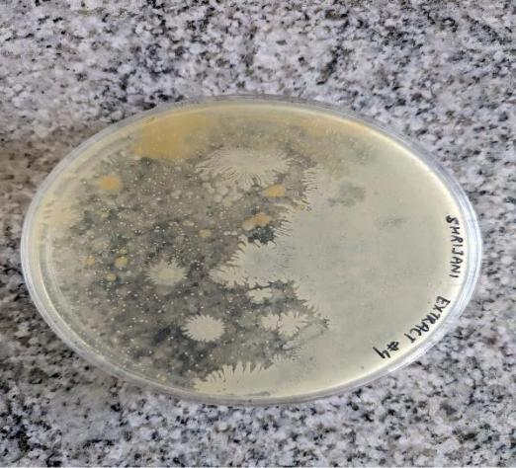

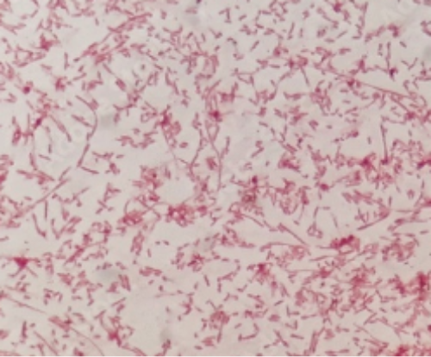

Gram staining – Gram Negative

**Plate 4: Golden Dewdrop (Duranta erecta) Extract**

* Was associated with **high bacterial proliferation** and significant contamination. Only rod-shaped bacteria were noted.
* Pink staining results confirmed predominance of Gram-negative bacteria.
* These outcomes denote minimal inhibitory potential for Golden Dewdrop under the tested conditions, despite some literature noting secondary metabolite-driven antibacterial effects in other systems. The observed selectivity may reflect differences in phytochemical profiles and extract concentrations, as plant extract efficacy is highly dependent on metabolite content, extraction method, and test bacterial strain.

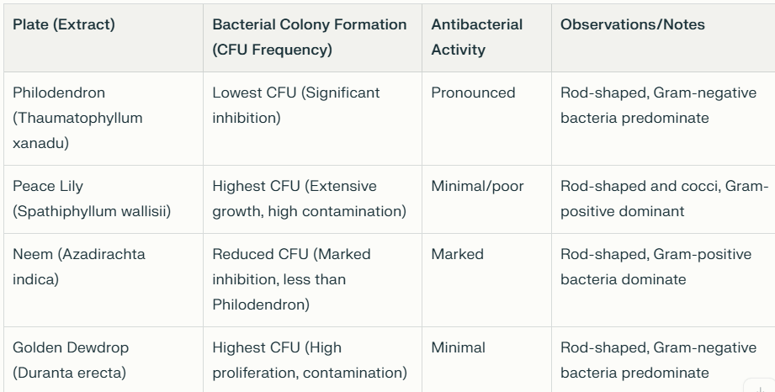

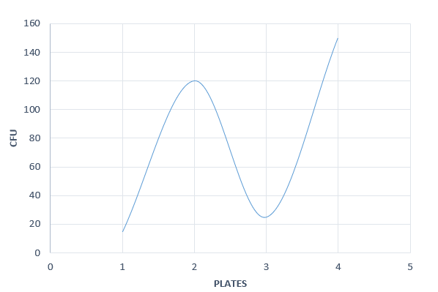

**Cultural Broth Observations and Growth Kinetics**

* Hourly measurements of optical density in broth cultures reinforced the plate assay results: cultures with Philodendron and Neem extracts exhibited a reduced growth curve trajectory, while Peace Lily and Golden Dewdrop paralleled control or untreated samples, reflecting less growth inhibition.
* Spectrophotometric growth curves and corresponding colony enumeration reaffirm the agar-based findings, quantitatively supporting the differential antibacterial efficacy observed.

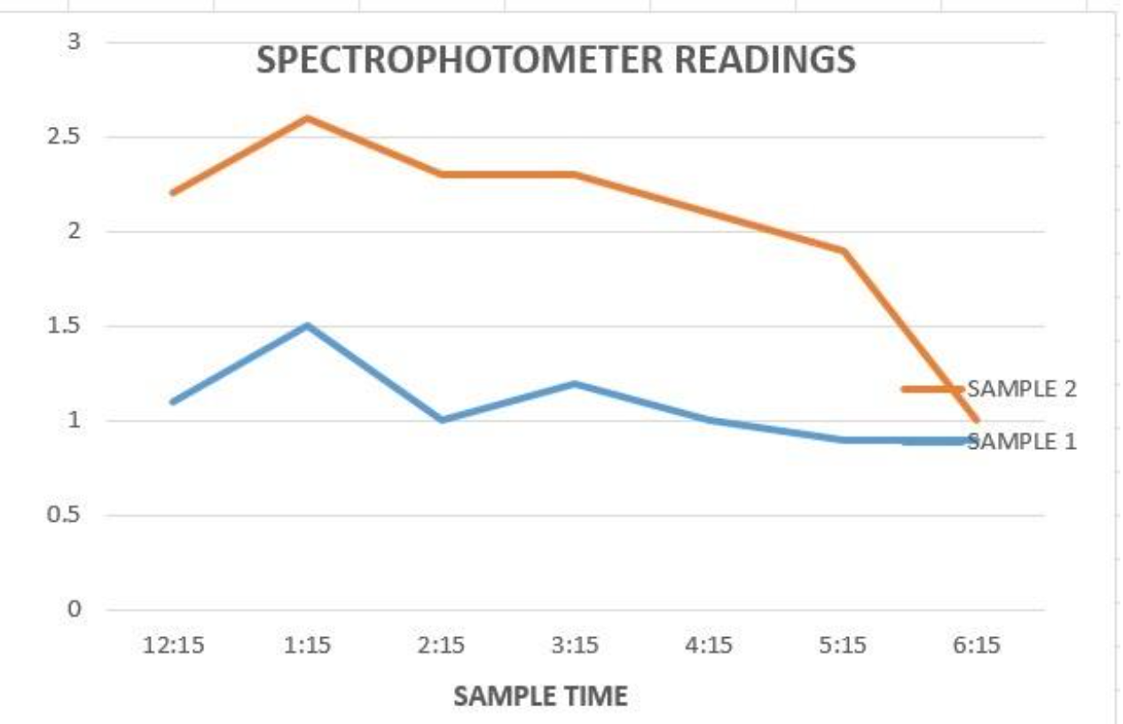

**Extended Discussion on Antibacterial Mechanisms of Plant Extracts**

The differential antibacterial activity observed among the extracts of *Thaumatophyllum xanadu* (Philodendron), *Azadirachta indica* (Neem), *Spathiphyllum wallisii* (Peace Lily), and *Duranta erecta* (Golden Dewdrop) can be attributed to the diverse phytochemical profiles and resultant bioactive compounds in each plant, which interact with bacterial cells through multiple complex mechanisms.

1. **Cell Membrane Disruption and Permeability Alteration:**  
   Both Gram-positive and Gram-negative bacteria rely on intact cytoplasmic membranes for vital functions. Many plant-derived compounds, such as phenolics, flavonoids, tannins, and alkaloids—known constituents in Philodendron and Neem—act by inserting into and disrupting bacterial membranes, leading to increased permeability, leakage of intracellular contents, and ultimately cell death. This disruption is often accompanied by alterations in membrane potential and proton motive force ([1](https://pmc.ncbi.nlm.nih.gov/articles/PMC6066648/)[3](https://www.frontiersin.org/journals/microbiology/articles/10.3389/fmicb.2018.01639/full)[7](https://www.sciencedirect.com/science/article/pii/S0944711321001690)). In your study, the potent activity of Philodendron and Neem extracts correlates with such membrane-targeting effects, aligning with evidence that bactericidal actions include hyperpolarization and reduced internal pH in bacterial cells.
2. **Inhibition of Cell Wall Synthesis and Integrity:**  
   Gram-positive bacteria possess thick peptidoglycan layers which are crucial for maintaining cell shape and osmotic stability. Certain plant secondary metabolites interfere with enzymes responsible for peptidoglycan synthesis (transpeptidases, autolysins), causing structural weaknesses and lysis. The prevalence of Gram-positive bacteria in Neem extract-treated samples, which was reduced compared to controls, suggests interference with these biosynthetic pathways ([4](https://journals.plos.org/plosone/article?id=10.1371%2Fjournal.pone.0274174)). Meanwhile, the persistence of Gram-negative bacteria, which have an outer membrane barrier, supports the notion of selective sensitivity.
3. **Enzyme Inhibition and Metabolic Disruption:**  
   Bioactive molecules, including azadirachtin and nimbolide from Neem, inhibit key bacterial enzymes and metabolic pathways, impairing cellular respiration, energy production, and nucleic acid synthesis. Disruption of ATPase activity, efflux pump inhibition, and interference with quorum sensing molecules are reported mechanisms contributing to antibacterial effects ([6](https://pmc.ncbi.nlm.nih.gov/articles/PMC8384518/)).
4. **Oxidative Stress Induction:**  
   Plant extracts often induce reactive oxygen species (ROS) generation in bacterial cells, causing damage to DNA, proteins, and lipids. Antioxidant phytochemicals in some plants may paradoxically lead to pro-oxidant effects selectively in microbes, compromising bacterial viability ([5](https://www.sciencedirect.com/science/article/pii/S2468227624003375)[8](https://www.mdpi.com/2076-3417/12/10/5038)).
5. **Biofilm Inhibition:**  
   Many soil bacteria form biofilms, a protective community resistant to antimicrobials. Some plant compounds disrupt biofilm formation and stability by inhibiting adhesion molecules or extracellular polymeric substances synthesis, rendering bacteria more susceptible to environmental stresses and antimicrobial agents ([4](https://journals.plos.org/plosone/article?id=10.1371%2Fjournal.pone.0274174)).
6. **Variability in Phytochemical Composition:**  
   The observed weak antibacterial activity in Peace Lily and Golden Dewdrop could stem from lower concentrations or absence of specific active compounds capable of penetrating bacterial defenses or effectively targeting vital cellular components. Additionally, the solvent system (aqueous with 1% acetone) and extraction methods influence the yield and spectrum of active metabolites available, impacting efficacy.

**Integration with Experimental Observations**

* The predominance of Gram-negative rods remaining in Philodendron-treated plates may reflect selective pressure, where susceptible Gram-positive bacteria were suppressed, illustrating the extract's broad spectrum but with differential potency.
* Neem’s significant reduction of Gram-positive bacteria aligns with known selective inhibitory effects on cell wall synthesis.
* Peace Lily and Golden Dewdrop’s inability to reduce bacterial colonies suggests their phytochemicals either lack potent antimicrobial constituents or the concentration/extraction method was insufficient to exert strong antibacterial action.
* The spectrophotometric growth curves further confirm that Philodendron and Neem extracts impede bacterial proliferation kinetics significantly more than the other extracts.

**Conclusion**

The antibacterial mechanisms of plant extracts are multifactorial, involving membrane disruption, inhibition of cell wall and metabolic functions, oxidative damage, and anti-biofilm activity. The efficacy observed for *Thaumatophyllum xanadu* and *Azadirachta indica* in your study is consistent with these well-established modes of action attributed to their rich phytochemical content. Conversely, the lower activity of *Spathiphyllum wallisii* and *Duranta erecta* highlights the critical role of phytochemical diversity and extraction efficiency in determining antimicrobial efficacy. Future work incorporating phytochemical profiling and mechanistic assays (e.g., membrane potential assays, enzyme inhibition tests, ROS quantification) would deepen understanding of these interactions.

Refrences

1. <https://pmc.ncbi.nlm.nih.gov/articles/PMC6066648/>
2. <https://www.nature.com/articles/s41598-023-36837-3>
3. <https://www.frontiersin.org/journals/microbiology/articles/10.3389/fmicb.2018.01639/full>
4. <https://journals.plos.org/plosone/article?id=10.1371%2Fjournal.pone.0274174>
5. <https://www.sciencedirect.com/science/article/pii/S2468227624003375>
6. <https://pmc.ncbi.nlm.nih.gov/articles/PMC8384518/>
7. <https://www.sciencedirect.com/science/article/pii/S0944711321001690>
8. <https://www.mdpi.com/2076-3417/12/10/5038>
9. Buwa, L.V. and Staden, J. V. (2006). Antibacterial and antifungal activity of traditional medicinal plants used against venereal diseases in South Africa. J. Ethnopharmacol. 103: 139-142.
10. Dabur, R., Ali, M., Singh, H., Gupta, J. and Sharma, G. L. (2004). A novel antifungal pyrrole derivative from Datura metel leaves. Pharmazie. 59(7): 568-570. 3) Dabur, R., Singh, H., Chhillar, A. K., Ali, M. and Sharma, G. L (2004). Antifungal potential of Indian medicinal plants. Fitoterapia. 75(3-4): 389-391
11. Dean, D. A. and Burchard, K. W. (1996). Fungal infection in surgical patients. Am J Surg. 171: 374-382. 5) Fromtling, R. A., Galgiani, J. N., Pfaller, M. A., Espinel-Ingroff, A., Bartizal, K. F., Bartlett, M. S., Body, B. A., Frey, C., Hall, G., Roberts, G. D. (1993). Multicenter evaluation of a broth microdilution antifungal susceptibility test for yeasts. Antimicrob Agents Che mother. 37(1): 39-45.
12. Gonzalez, C. E., Venzon, D., Lee, S., Mueller, B. U., Pizzo, P. A and Walsh, T. J. (1996). Risk factors for fungemia in children infected with human immunodeficiency virus: a case-control study. Clin Infect Dis. 23: 515-521. 7) Graybill, J. R. (1988). Systemic fungal infections: diagnosis and treatment. I. Therapeutic agents. Infectious Disease Clinics of North America. 805-825.
13. Narang, G. D., Nayar, S., Mcndiratta, D. K . (1962). Antibacterial activity of some indigenous drugs. J. Vet. Anim. Husb. Res. 6(1): 22-25. 9) Ng, P. C. (1994). Systemic fungal infections in neonates. Arch Dis of Childhood. 71: F130-F135.
14. Sieradzki K, Wu SW and Tomasz A. (1999). Inactivation of the methicillin resistance gene mecA in vancomycin-resistant Staphylococcus aureus. Micro. Drug Resist. 5(4): 253-257.
15. Maciel MAM, Pinto AC, Veiga Jr VF, Grynberg NF, Echevarria A. Medicinal plants: the need for multidisciplinary scientific studies. Quim Nova. 2002;25(3):429-38.
16. Cowan MM. Plant products as antimicrobial agents. Clin Microbiol Rev. 1999; 12(4):564-82.
17. Carvalho ACB, Nunes DSG, Baratelli TG, Shuqair NSMSAQ, Machado Netto E. Aspectos da legislação no controle dos medicamentos fitoterápicos. T&C Amazônia. 2007;5(11):26-32.
18. Funari CS, Ferro VO. Ethical use of the Brazilian biodiversity: necessity and opportunity. Rev Bras Farmacogn. 2005;15(2):178-82.
19. Niero R. Fármacos, fitofármacos e fitoterápicos: abordagem econômica e de mercado. In: Bresolin TMB, Cechinel Filho V, editors. Fármacos e medicamentos. Uma abordagem multidisciplinar. São Paulo: Editora Santos; 2010. p. 1-15.
20. Nascimento GGF, Locatelli J, Freitas PC, Silva GL. Antibacterial activity of plant extracts and phytochemicals on antibiotic-resistant bacteria. Braz J Microbiol. 2000;31(1):247-56.
21. . Sakagami Y, Kajimura K. Bactericidal activities of disinfectants against vancomycin-resistant enterococci. J Hosp Infec. 2002;50(2):140-4.
22. . Chartone-Souza E. Bactérias ultra-resistentes: uma guerra quase perdida. Cienc Hoje. 1998;23(138):27-35.
23. . Avancini CAM, Wiest JM, Mundstock EA. Bacteriostatic and bactericidal activity of the *Baccharis trimera* (Less.) D.C. Compositae decocto, as disinfectant or antisseptic. Arq Bras Med Vet Zootec. 2000;52(3):230-4.
24. . Alzoreky NS, Nakahara K. Antibacterial activity of extracts from some edible plants commonly consumed in Asia. Int J Food Microbiol. 2003;80(3):223-30.
25. . Machado TB, Pinto AV, Pinto MC, Leal ICR, Silva MG, Amaral ACF, et al. *In vitro* activity of Brazilian medicinal plants, naturally occurring naphthoquinones and their analogues, against methicillin-resistant *Staphylococcus aureus* Int J Antimicrob Agents. 2003;21(3):279-84.
26. Candan F, Unlu M, Tepe B, Daferera D, Polissiou M, Sokmen A, et al. Antioxidant and antimicrobial activity of the essential oil and methanol extracts of *Achillea millefolium* subsp. *millefolium* Afan. (Asteraceae). J Ethnopharmacol. 2003;87(2-3):215-20.
27. Menezes MC, Souza MMS, Botelho RP. *In vitro*evaluation of antimicrobial activity of Brazilian plants extracts on bacteria isolated from oral cavity of dogs. Rev Univ Rural. 2004;24(2):141-4.
28. Asolini FC, Tedesco AM, Ferraz C, Alencar SM, Carpes ST. Antioxidant and antibacterial activities of phenolic compounds in extracts of plants used as tea. Braz J Food Technol. 2006;9(6):209-15.
29. . Gallucci N, Casero C, Oliva M, Zygadlo J, Demo M. Interaction between terpenes and penicillin on bacterial strains resistant to beta-lactam antibiotics. Mol Med Chem. 2006;10(1):30-2.
30. . Duarte MCT, Delarmelina C, Figueira GM, Sartoratto A, Rehder VLG. Effects of essential oils from medicinal plants used in Brazil against EPEC and ETEC *Escherichia coli* Rev Bras PI Med. 2006;8(n.esp.):139-43.
31. . Betoni JE, Mantovani RP, Barbosa LN, Di Stasi LC, Fernandes Jr A. Synergism between plant extract and antimicrobial drugs used on *Staphylococcus aureus* diseases. Mem Inst Oswaldo Cruz. 2006;101(4):387-90.
32. . Oliveira DG, Prince KA, Higuchi CT, Santos ACB, Lopes LMX, Simões MJS, et al. Antimycobacterial activity of some Brazilian indigenous medicinal drinks. J Basic Appl Pharm Sci. 2007;28(2):165-9.
33. . Braga FG, Bouzada ML, Fabri RL, Matos MO, Moreira FO, Scio E, et al. Antileishmanial and antifungal activity of plants used in traditional medicine in Brazil. J Ethnopharmacol. 2007;111(2):396-402.
34. . Ferronato R, Marchesan ED, Pezenti E, Bednarski F, Onofre SB. Antimicrobial activity of essential oils produced by *Baccharis dracunculifolia* D.C. and *Baccharis uncinella* D.C. (Asteraceae). Rev Bras Pharmacogn. 2007;17(2):224-30.
35. Rosato A, Vitali C, Laurentis N, Armenise D, Milillo MA. Antibacterial effect of some essential oils administered alone or in combination with norfloxacin. Phytomedicine. 2007;14(11):727-32.
36. . Ushimaru PI, Silva MTN, Di Stasi LC, Barbosa L, Fernandes Jr A. Antibacterial activity of medicinal plant extracts. Braz J Microbiol. 2007;38(1):717-9.
37. . Costa JGM, Rodrigues FFG, Angélico EC, Pereira CKB, Souza EO, Caldas GFR, et al. Chemical composition and evaluation of the antibacterial activity and toxicity of the essential oil of *Croton zehntneri* (variety estragol). Rev Bras Pharmacogn. 2008; 18(4):583-6.
38. . Oliveira IS, Lima JCS, Silva RM, Martins DTO. *In vitro* screening of antibacterial activity of the latex and extracts from *Croton urucurana* Baillon. Rev Bras Pharmacogn. 2008;18(4):587-93.
39. . More GK, Tshikalange TE, Lall N, Botha FS, Meyer JJM. Antimicrobial activity of medicinal plants against oral microorganisms. J Ethnopharmacol. 2008;119(1):473-7.
40. . Aguiar JS, Costa MCCD, Nascimento SC, Sena KXFR. Antimicrobial activity of *Lippia alba* (Mill.) N. E. Brown (Verbenaceae). Rev Bras Pharmacogn. 2008; 18(3):436-40.
41. Coutinho HDM, Costa JGM, Siqueira-Júnior JP, Lima EO. *In vitro* anti-staphylococcal activity of *Hyptis martiusii* Benth against methicillin-resistant *Staphylococcus aureus* MRSA strains. Rev Bras Pharmacogn. 2008;18(Supl.):670-5.
42. Salvagnini LE, Oliveira JRS, Santos LE, Moreira RRD, Pietro RCLR. Evaluation of the antibacterial activity of *Myrtus communis* L. (Myrtaceae) leaves. Rev Bras Pharmacogn. 2008;18(2):241-4.
43. Silva MAR, Higino JS, Pereira JV, Siqueira-Júnior JP, Pereira MSV. Antibiotic activity of the extract of *Punica granatum* Linn. over bovine strains of *Staphylococcus aureus* Rev Bras Pharmacogn. 2008;18(2):209-12.
44. . Silva MSA, Silva MAR, Higino JS, Pereira MSV, Carvalho AAT. *In vitro* antimicrobial activity and antiadherence of *Rosmarinus officinalis*Linn. against oral planktonic bacteria. Rev Bras Pharmacogn. 2008;18(2):236-40.
45. Barbosa LN, Rall VL, Fernandes AA, Ushimaru PI, da Silva Probst I, Fernandes A Jr. Essential oils against foodborne pathogens and spoilage bacteria in minced meat. Foodborne Pathog Dis. 2009;6(6):725-8.
46. Silva Jr. IE, Cechinel Filho V, Zacchino SA, Lima JCS, Martins DTO. Antimicrobial screening of some medicinal plants from Mato Grosso Cerrado. Rev Bras Pharmacogn. 2009;19(1B):242-8.
47. . Costa AC, Santos BHC, Santos Filho L, Lima EO. Antibacterial activity of the essential oil of *Origanum vulgare* L. (Lamiaceae) against bacterial multiresistant strains isolated from nosocomial patients. Rev Bras Pharmacogn. 2009;19(1B):236-41.
48. . Zampini IC, Cuello S, Alberto MR, Ordonez RM, D'Almeida R, Solorzano E, et al. antimicrobial activity of selected plant species from "the Argentine Puna" against sensitive and multiresistant bacteria. J Ethnopharmacol. 2009;124(3):499-505.
49. . Silva MTN, Ushimaru PI, Barbosa LN, Cunha MLRS, Fernandes Jr A. Antibacterial activity of plant essential oils against *Staphylococcus aureus* and *Escherichia coli* strains isolated from human specimens. Rev Bras PI Med. 2009; 11(3):257-62.
50. Mbosso EJ, Ngouela S, Nguedia JC, Beng VP, Rohmer M, Tsamo E. *In vitro* antimicrobial activity of extracts and compounds of some selected medicinal plants from Cameroon. J Ethnopharmacol. 2010;128(2):476-81.
51. Barbosa LN. Propriedade antimicrobiana de óleos essenciais de plantas condimentares com potencial de uso como conservantes em carne e hambúrguer bovino e testes de aceitação [thesis]. Botucatu: Universidade Estadual Paulista, Instituto de Biociências; 2010. 107 p.
52. . Szalek E, Grzeskowiak E, Kozielczyk J. Interactions between herbal and synthetic drugs. Advantages and risks. Herba Polonica. 2006;52(4):153-7.
53. . Ushimaru PI. Estudo *in vitro* da atividade antibacteriana de extratos de plantas medicinais e sinergismo com drogas antimicrobianas [thesis]. Botucatu: Universidade Estadual Paulista, Instituto de Biociências; 2007. 51 p.
54. . Oliveira RAG, Lima EO, Vieira WL, Freire KRL, Trajano VN, Lima IO, et al. Study of the interference of essential oils on the activity of some antibiotic used clinically. Rev Bras Pharmacogn. 2006;16(1):77-82.
55. . Shin S. Anti-*Aspergillus* activities of plant essential oils and their combination effects with ketoconazole or amphotericin B. Arch Pharm Res. 2003;26(5):389-93.
56. Shin S, Kang CA. Antifungal activity of the essential oil of *Agastache rugosa* Kuntze and its synergism with ketoconazole. Lett Appl Microbiol. 2003;36(2):111-5.
57. . van Vuuren SF, Suliman S, Viljoen AM. The antimicrobial activity of four commercial essential oils in combination with conventional antimicrobials. Lett Appl Microbiol. 2009;48(4):440-6.
58. . Probst I. Ação antibacteriana de extrato etanólico de própolis e óleos essenciais de plantas medicinais e sinergismo entre estes produtos naturais. Botucatu: Universidade Estadual Paulista, Instituto de Biociências; 2009. 41 p.
59. . Zago JAA, Ushimaru PI, Barbosa LN, Fernandes Jr A. Synergism between essential oils and antimicrobial drugs against *Staphylooccus aureus* and *Escherichia coli* strains from human infections. Rev Bras Pharmacogn. 2009;19(4):828-33.
60. . Silva NCC. Estudo comparativo da ação antimicrobiana de extratos e óleos essenciais de plantas medicinais e sinergismo com drogas antimicrobianas [thesis]. Botucatu: Universidade Estadual Paulista, Instituto de Biociências; 2010. 67 p.
61. . Knobloch K, Pauli A, Iberl B. Antibacterial and antifungal properties of essential oil components. J Essent Oil Res. 1989;1(3):119-28.
62. . Burt S. Essential oils: their antibacterial properties and potential applications in foods a review. Int J Food Microbiol. 2004;94(3):233-53.
63. . Sikkema J, de Bont JA, Poolman B. Interactions of cyclic hydrocarbons with biological membranes. J Biol Chem. 1994;269(11):80228.
64. . Sikkema J, de Bont JA, Poolman B. Mechanisms of membrane toxicity of hydrocarbons. Microbiol Rev. 1995;59(2):201-22.
65. . Conner DE, Beuchat LR. Effects of essential oils from plants on growth of food spoilage yeasts. J Food Sci. 1984;49(2):429-34.
66. . Lambert RJW, Skandamis PN, Coote P, Nychas GJE. A study of the minimum inhibitory concentration and mode of action of oregano essential oil, thymol and carvacrol. J Appl Microbiol. 2001;91(3):453-62.
67. . Helander IM, Alakomi HL, Latva-Kala K, Mattila-Sandholm T, Pol I, Smid EJ, et al. Characterization of the action of selected essential oil components on gram-negative bacteria. J Agric Food Chem. 1998;46(9):3590-5.
68. . Thoroski J, Blank G, Biliaderis C. Eugenol induced inhibition of extracellular enzyme production by *Bacillus cereus* J Food Prot. 1989;52(6):399-403.
69. . Ultee A, Bennink MHJ, Moezelaar R. The phenolic hydroxyl group of carvacrol is essential for action against the food-borne pathogen *Bacillus cereus* Appl Environ Microbiol. 2002;68(4):1561-8.
70. . Oosterhaven K, Poolman B, Smid EJ. S-carvone as a natural potato sprout inhibiting, fungistatic and bacteristatic compound. Ind Crops Prod. 1995;4(1):23-31.
71. . Wendakoon CN, Sakaguchi M. Inhibition of amino acid decarboxylase activity of Enterobacter aerogenes by active components in spices. J Food Prot. 1995; 58(3):280-3.
72. <https://doi.org/10.1089/acm.1995.1.131>
73. Cowan, M. M. (1999). Plant products as antimicrobial agents. *Clinical Microbiology Reviews*, 12(4), 564–582. <https://doi.org/10.1128/cmr.12.4.564>
74. Sarup Didwana, V., & Sharma, N. (2025). Ethnobotanical and Pharmacological Evaluation of Indian Medicinal Plants: Towards Evidence-Based Applications. *The Bioscan*, 20(2), S273–S277.
75. Harwansh, R. K., Banerjee, S., & Kar, A. (2024). Evidence-Based Validation of Indian Traditional Medicine: Way Forward. In *World Journal of Traditional Chinese Medicine*
76. <https://pmc.ncbi.nlm.nih.gov/articles/PMC4689034/>
77. Boos, J. (2008). Philodendron xanadu origin and cultivation notes. *International Aroid Society Journal Aroideana*, 31.
78. *Aroideana; Journal of the International Aroid Society* 25: 63 (2002 publ. 2003)
79. [San Marcos Growers website](http://www.smgrowers.com/products/plants/plantdisplay.asp?plant_id=2620)
80. [*"Philodendron xanadu (Winterbourn Philodendron, Xanadu Philodendron) | North Carolina Extension Gardener Plant Toolbox"*](https://plants.ces.ncsu.edu/plants/philodendron-xanadu/)*. plants.ces.ncsu.edu. Retrieved 8 May 2025.*
81. [San Marcos Growers website](http://www.smgrowers.com/products/plants/plantdisplay.asp?plant_id=2620)
82. [Julius Boos, *Philodendron xanadu*, Araceum website](http://abrimaal.pro-e.pl/araceum/philodendron/xanadu.htm)
83. Brown, D. (1988). Aroids: Plants of the Arum Family. Portland, OR: Timber Press, 1988
84. Mayo, S. J. (1990).History and Infrageneric Nomenclature of Philodendron (Araceae). Kew Bulletin. Vol. 45, No. 1, pp. 37–71
85. Mayo, S. J. (1991). A revision of Philodendron subgenus Meconostigma (Araceae). Kew Bulletin 46: 601-681
86. Spathiphyllum. Wikipedia. Retrieved from https://en.wikipedia.org/wiki/Spathiphyllum
87. North Carolina State University, Plant Toolbox: Philodendron xanadu (related species in Araceae family). Retrieved from https://plants.ces.ncsu.edu/plants/spathiphyllum/
88. harma, R. C., Lavanya, V., Kumar, A., Prasanna, K. L., & Kumar, M. (2023). The role of neem in integrated pest management: A sustainable approach for mulberry ecosystem protection. Journal of Entomology and Zoology Studies, 11(6), 132-143. https://doi.org/10.22271/j.ento.2023.v11.i6b.9449
89. Campos, E. V. R., de Oliveira, J. L., Fraceto, L. F., & Singh, B. (2016). Neem oil and crop protection: From now to the future. Frontiers in Plant Science, 7, 610. https://doi.org/10.3389/fpls.2016.00610
90. Schmutterer, H. (1990). Properties and potential of natural pesticides from the neem tree, Azadirachta indica. Annual Review of Entomology, 35, 271-297. https://doi.org/10.1146/annurev.en.35.010190.001415
91. 91 Breed, R. S., & Dotterrer, W. D. (1916). The number of colonies allowable on satisfactory agar plates. Journal of Bacteriology, 1(3), 321–331.
92. 92.Plate count - an overview. (n.d.). ScienceDirect Topics. <https://www.sciencedirect.com/topics/immunology-and-microbiology/plate-count>
93. Habtewold, J., Pool, T., & Abdi, S. (2018). Isolation and analysis of microbial communities in soil, rhizosphere, and endosphere using DNA sequencing methods. *Methods in Molecular Biology*, 1849, 1-93. <https://www.ncbi.nlm.nih.gov/pmc/articles/PMC6126543/>
94. 94.Processors & Growers Research Organisation (PGRO). (2021). Guide when sampling soil for microbe analysis. <https://www.pgro.org/downloads/TU42-GuidewhenSamplingSoilforMicrobeAnalysis21.pdf>
95. 95.Environmental Protection Agency (EPA). (2015). Soil Sampling Procedures Document. <https://www.epa.gov/sites/default/files/2015-06/documents/Soil-Sampling.pdf>
96. 96.Hossain, T. J. (2024). Methods for screening and evaluation of antimicrobial activity. *PMC*, <https://pmc.ncbi.nlm.nih.gov/articles/PMC11097785/>

97.Microbiology Lab Manual. (2023). Preparation of culture media. University of Mustansiriyah, <https://uomustansiriyah.edu.iq/media/lectures/6/6_2023_10_28!04_58_54_PM.pdf>

98.Sigma-Aldrich Technical Article. (2025). Microbial culture media preparation. <https://www.sigmaaldrich.com/IN/en/technical-documents/technical-article/microbiological-testing/microbial-culture-media-preparation/media-preparation>

99.Microbiology Info. (2022). Nutrient Agar: Composition, Preparation and Uses. <https://microbiologyinfo.com/nutrient-agar-composition-preparation-and-uses/>

1. 100. Koch AL. Some calculations on the turbidity of mitochondria and bacteria. Biochem Biophys Acta. 1961;51:429–441. [[DOI](https://doi.org/10.1016/0006-3002(61)90599-6)] [[PubMed](https://pubmed.ncbi.nlm.nih.gov/14457538/)] [[Google Scholar](https://scholar.google.com/scholar_lookup?journal=Biochem%20Biophys%20Acta&title=Some%20calculations%20on%20the%20turbidity%20of%20mitochondria%20and%20bacteria&author=AL%20Koch&volume=51&publication_year=1961&pages=429-441&pmid=14457538&doi=10.1016/0006-3002(61)90599-6&)]
2. Koch AL. Turbidity measurements of bacterial cultures in some available commercial instruments. Anal Biochem. 1970;38:252–259. [[DOI](https://doi.org/10.1016/0003-2697(70)90174-0)] [[PubMed](https://pubmed.ncbi.nlm.nih.gov/4920662/)] [[Google Scholar](https://scholar.google.com/scholar_lookup?journal=Anal%20Biochem&title=Turbidity%20measurements%20of%20bacterial%20cultures%20in%20some%20available%20commercial%20instruments&author=AL%20Koch&volume=38&publication_year=1970&pages=252-259&pmid=4920662&doi=10.1016/0003-2697(70)90174-0&)]
3. Swinehart DF. The Beer‐Lambert law. J Chem Educ. 1962;39:333. [[Google Scholar](https://scholar.google.com/scholar_lookup?journal=J%20Chem%20Educ&title=The%20Beer%E2%80%90Lambert%20law&author=DF%20Swinehart&volume=39&publication_year=1962&pages=333&)]
4. Stevenson K, McVey AF, Clark IBN, Swain PS, Pilizota T. General calibration of microbial growth in microplate readers. Sci Rep. 2016;6:38828. [[DOI](https://doi.org/10.1038/srep38828)] [[PMC free article](https://pmc.ncbi.nlm.nih.gov/articles/PMC5153849/)] [[PubMed](https://pubmed.ncbi.nlm.nih.gov/27958314/)] [[Google Scholar](https://scholar.google.com/scholar_lookup?journal=Sci%20Rep&title=General%20calibration%20of%20microbial%20growth%20in%20microplate%20readers&author=K%20Stevenson&author=AF%20McVey&author=IBN%20Clark&author=PS%20Swain&author=T%20Pilizota&volume=6&publication_year=2016&pages=38828&pmid=27958314&doi=10.1038/srep38828&)]
5. Beal J, Farny NG, Haddock‐Angelli T, Selvarajah V, Baldwin GS, Buckley‐Taylor R, et al. Robust estimation of bacterial cell count from optical density. Commun Biol. 2020;3:512. [[DOI](https://doi.org/10.1038/s42003-020-01127-5)] [[PMC free article](https://pmc.ncbi.nlm.nih.gov/articles/PMC7499192/)] [[PubMed](https://pubmed.ncbi.nlm.nih.gov/32943734/)] [[Google Scholar](https://scholar.google.com/scholar_lookup?journal=Commun%20Biol&title=Robust%20estimation%20of%20bacterial%20cell%20count%20from%20optical%20density&author=J%20Beal&author=NG%20Farny&author=T%20Haddock%E2%80%90Angelli&author=V%20Selvarajah&author=GS%20Baldwin&volume=3&publication_year=2020&pages=512&pmid=32943734&doi=10.1038/s42003-020-01127-5&)]
6. Abubakar, A. R., & Haque, M. (2020). Preparation of medicinal plants: Basic extraction and fractionation procedures for experimental purposes. *Journal of Pharmacy & Bioallied Sciences*, 12(1), 1-10.
7. Sasidharan, S., et al. (2010). Extraction, Isolation and Characterization of Bioactive Compounds from Plants’ Extracts. African Journal of Traditional, Complementary, and Alternative Medicines, 8(1), 1–10.
8. Bose, T. K., Chowdhury, B., Sharma, S. P. (2008). *Cactus and other succulents. Tropical garden plants in colour* (Chapter 5, pp. 319–426). Horticulture and Allied Publishers, India.